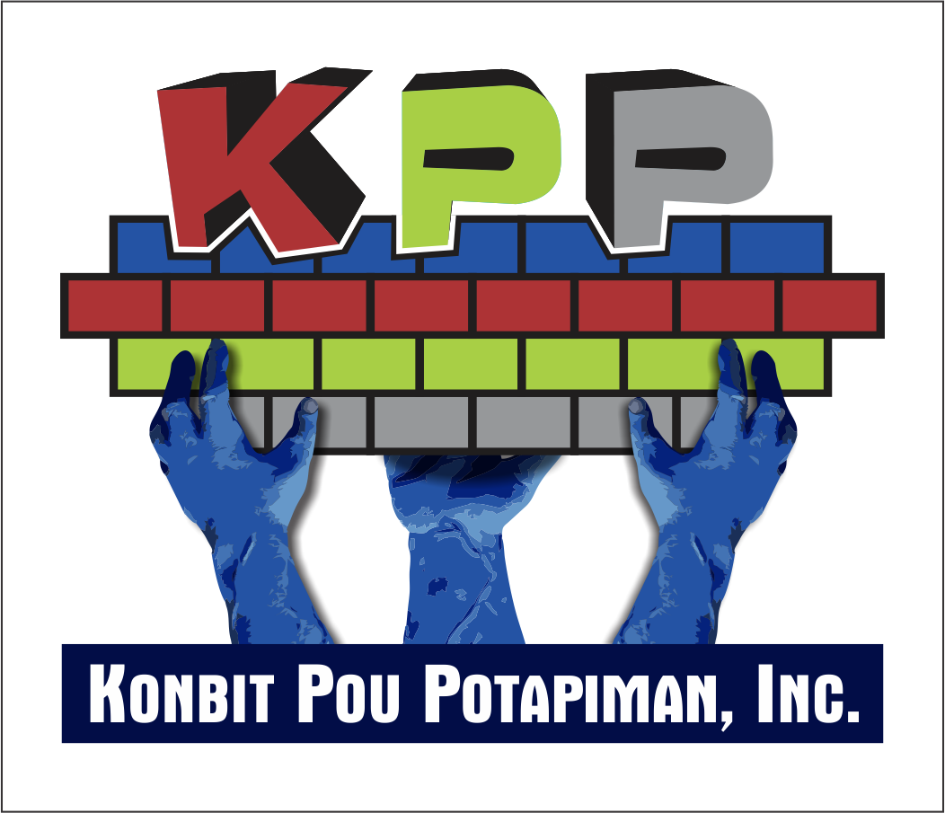

Good evening.

Thank you Serge, Thank you so much!

Ladies and Gentlemen, on behalf of the board of Directors of Konbit Pou Potapiman Inc, we thank you all for your presence. It is a great pleasure to see many of you with us again at the KPP 5th Annual fundraising event. We also want to recognize many new friends who are here with us for the first time. We extend to you a warm welcome.

Tonight, I invite all of you to consider the work done. On your table, there is list of our accomplishments for this year. Please take the time to glance through it. I will also encourage you to follow our progress and challenges on our website at portapiment.com.

Some of our programs such as the Annual Health Fair, the Summer Camp for kids, the Eric Belfort Student’s Awards of Excellence, the Dr. Charles Sinady teacher‘s Awards of Excellence, the Sponsorship Program are now well established.

However, last July, and for the first time, KPP was fortunate to be able to recognize 4 outstanding retired educators, who molded generations of Port-a-Pimentais, and to whom we owe a debt of gratitude. Could any of us, who has grown in Port-a-Piment, not remember the valuable teachings and the dedication of Miss Elvire Damas, Mr Nerva Pascal, Miss Therese Auguste, Miss Paulette Romelus. These fine individuals were honored on their special day, and this gesture was very much appreciated by the recipients and their families.

These four retired teachers received the Anne Muller St Gerard Recognition Certificate which was made possible by Dr Serge St Gerard, to honor his mom’s life and to commemorate her enthusiasm for community service and her devotion to teaching. On behalf of all portapimentais and the Board of directors we thank you Dr St- Gerard. Mèsi anpil!

-Thanks to the generosity of the present director of the EFACAP school, Mr Maxo Pierre-Louis, KPP was able to open a Children’s library in one of the unused spaces of the school. However, as scheduling conflicts developed, it became obvious to us that the library should be independent of a school, so that its days or hours of operation are not restricted by the academic schedule, and so that all children from the commune have an easy access to it.

We are proud to inform you that KPP has been able to secure a piece of land in the center of town to build the first Children’s Library of Port-a-Piment. Many obstacles had to be overcome and KPP is so very grateful to Marcelin Emile, Jean Marc Auguste, Lafa Deriveau, and to Mayor Edouard Laurole for their invaluable help.

We have a special guest with us tonight. This friend of mine, a passionate native of Gonaives, is an Engineer Architect who, without hesitation, volunteered and designed the plan for the library. Ladies and Gentlemen, please help me welcome Ing. Serge Sajous. Thank you Serge for your support and your contribution to my lovely town!

In the coming months, KPP will start the process of securing the funds to build the library. KPP will be knocking on all doors and we will apply for help with different international organizations so we can make this Children’s Library a viable institution in our town.

Last April, armed with a well-designed project, KPP-Haiti was able to secure the funding of over 3500 US dollars from the One World Group Oxted of England for its Breeding of Goats and Sheep project.

20 families from the poor villages of Dupin and Pinette now own 2 goats or sheep and have started to increase the family’s wealth. The goal is to extend the project to neighboring villages through a Receive and Give concept where the original recipients of goats or sheep must share the first litter with the next family in line.
.
We are happy to report that the project is doing well. During my visit to Port-a-Piment last summer, I met some of the owners, witnessed the care given to the animals and I can attest to the gratefulness of the beneficiaries who now can envision a better future for their families..

-. The Grotte Marie Jeanne project is ongoing. In partnership with the Haitian Department of Tourism, UNEP (United Nations Environmental Program) KPP-Haiti continues working on improving access to this national treasure. The Welcome center called Sant dAkey has been built; a well and public toilets have also been built. We are now awaiting the release of funds to complete the work.

Also, we would like to report that KPP has been helping our local farmers overcome their latest hardships. As many of you may know, the South of Haiti has been hit by a devastating drought. Some farmers lost their entire crops. KPP was there to give a helping hand. Last month, KPP provided 30 farmers with the seeds needed to prepare the next farming season.

Ladies and Gentlemen, so far, our goals for the year are being met and they couldn’t be reached without your financial support, your encouragement and also the active participation of family and friends.

And now may I take the time to extend a special welcome and to express our Thanks to 3 of the doctors who provided care, free of charge, at our last Health Fair in Port-a-Piment, and who are with us tonight.

We welcome Dr Levelt Jean, who has traveled from Haiti for this special occasion. You may be meeting him for the first time, but Dr Levelt is a constant at the KPP-AMH Health Fairs. Besides providing consultations to the patients, Dr Levelt distinguishes himself by holding educational sessions on Hygiene, on Diabetes, on Hypertension…. for the patients in the waiting room. Thank you so much Dr. Levelt! We appreciate all you do for our hometown.

And we welcome my dear daughter. Dr Dominique-Aimee Jean, who is here with us from Los Angeles. Dominique is getting to love Port-a-Piment just as much as her dad does. Thank you Domi, I am proud of you.

We are especially grateful to those of you who have honored the pledges made at our function last year. Thanks to you, the number of camp participants increased, the library opened for longer hours, and more services were provided at our last Health fair. Special recognition goes to Dr Yolaine Sinady for her extraordinary support. (Dr Sinady could not be with us tonight). Also a special Thank You from dozens of grateful children of Port-a-Piment to all the Sponsors who continue to provide for their educational needs through the KPP Sponsorship Program.

I would like to recognize Dr Eileen Davis Jerome, President of the Broward County Chapter of the UNITED NATIONS ASSOCIATION of USA. Dr Jerome has been collaborating with KPP for years. Thank you for your presence tonight.

Thank you to all who have traveled from Boston, Orlando, Los Angeles, Maryland, New York, Haiti… to show how much you care.

Finally, I would like to extend a heartfelt thanks to my colleagues on the Board of Directors, Carolle, Geto, Claudel, Serge, Gerald for their unwavering support. A special Thank You to KPP members Yves Sidney, Edu Jean Marie, Rene Val, Danie Lubin, for all the hard work on behalf of our town. To my wife Nicole for her exceptional and extraordinary support, we thank you so much.
---------------------------------------------------------------------------------------------------------
May I now introduce to you Dr Henriot ST Gerard, President of the Class of 72 of the Association des Médecins Haitiens à l’étranger

Dr St Gerard and the Class of 72 have been active in Port-a-Piment helping to strengthen the services of the local hospital.

Dr St Gerard will give us a brief update of their work.

